# Cost-effectiveness of a novel syphilis test:

# Full input parameters, and sensitivity analyses

## Disease state definitions

Syphilis infection progresses through a series of clinically defined stages over several years – primary, secondary, early latent, late latent and tertiary. Infection in the primary to early latent stages is considered to pose the highest risk of sexual transmission, but tertiary syphilis continues to damage internal organs. Additionally, syphilis antibodies persist after treatment which complicates diagnostic discrimination of current versus past-treated cases.

We define current infection as infection with the bacterial infectious agent present, in any clinical stage.

We define past-treated infection by absence of the bacterial infectious agent and presence of syphilis antibodies.

## Model structure

The model is a decision-tree model created in Microsoft Excel and simulates one round of testing (for instance, everyone’s first test of the year) for 100 hypothetical urban Australian MSM (current syphilis infection prevalence 1.8%).

In the status quo scenario, each MSM either attends a healthcare clinic for laboratory testing, or does not test.

In the intervention scenario, each MSM either attends a healthcare clinic, or takes a self-test and based on the result possibly attends a healthcare clinic, or does not test.

Each test taken in both scenarios is associated with a probability of returning a true positive, false positive, true negative or false negative result. For the self-test, the result influences the probability of attending confirmatory clinic testing. For the clinic tests, the combination of laboratory results determines whether a patient receives a correct diagnosis.

## Model input parameters

### Test uptake parameters

These parameters describe the testing behaviour of urban MSM in the model and are illustrated by the figure in the poster.

The Standard of Care Coverage value is derived from the most recent available capital city reports (as opposed to statewide reports) from UNSW’s GBQ+ Community Periodic Surveys [1]. City-specific values were calculated from a weighted average across HIV-positive and HIV-negative participants. The value used in the model is an average of these city-specific values.

The remaining uptake parameters are poorly constrained by available data. Our baseline estimates aimed to preserve the percentage of adopters among all self-testers at approximately 20%, as per HIV self-test figures from [2]. Due to the uncertainty surrounding these parameters, they form the focus of sensitivity analyses.

Internal preliminary qualitative investigations have suggested that a high proportion of currently testing MSM would like to use syphilis self-tests, especially with the potential for both syphilis and HIV self-tests to be performed together, but many would additionally seek to retain the supportive and more holistic care provided their relationship with their clinician.

The Healthcare LTFU rate is low to reflect the high public health priority given to active syphilis cases.

The Adopter LTFU rate conservatively assumes a proportion of current non-testers experience barriers to clinic testing that would also hinder follow-up of a positive self-test, hence the Adopter LTFU is higher than might be expected for the population in general.

### Table 1: Test uptake parameters

| **Parameter** | **Definition** | **Baseline Estimate** |
| --- | --- | --- |
| Standard of Care Coverage | Population proportion of MSM who attend at least one clinic testing appointment for syphilis in a given year, in the status quo scenario | 67.7% |
| Adopters | Number of MSM who do not currently test for syphilis under status quo, and who use a self-test in the intervention scenario | 12 |
| Switchers | Number of MSM who currently attend clinic testing under status quo, who begin using self-tests in the intervention scenario | 50 |
| Complement rate | Proportion of switchers who still attend their scheduled clinic test even with a negative self-test result (thus complementing rather than replacing clinic testing) | 70% |
| Adopter Loss to Follow-Up (LTFU) rate | Proportion of adopters who receive a positive self-test result but do not proceed to a clinic for confirmatory testing and treatment | 10% |
| Healthcare LTFU rate | Proportion of MSM attending each clinic appointment that fail to attend the next required appointment in the care cascade | 1% |

### Epidemiological parameters

Data on syphilis prevalence among MSM was sourced from The Australian Collaboration for Coordinated Enhanced Sentinel Surveillance of Sexually Transmissible Infections and Blood Borne Viruses project (ACCESS). ACCESS maintains a database of deidentified sexual health data from a network of healthcare providers and pathology laboratories around Australia [3]. Data was from the year 2024 and drawn from 43,357 MSM participants.

Estimates for the proportion of syphilis cases in each stage were produced from unpublished modelling using 2024 ACCESS data.

### Table 2: Epidemiological parameters

| **Parameter** | **Value** |
| --- | --- |
| Proportion of syphilis cases in each stage (primary, secondary, early latent, late latent, tertiary) | 11%, 8%, 62%, 18%, 1% |
| MSM population proportion never infected | 82.32% |
| MSM population proportion with past-treated infection only | 15.88% |
| MSM population proportion with current infection only | 0.39% |
| MSM population proportion with current and past-treated infection | 1.41% |

### Test parameters

The model input for sensitivity of laboratory tests used under the status quo (two TP-specific tests and RPR) was calculated by averaging test brands commonly used in Australia and with available data for sensitivity stratified by disease stage, weighted by the prevalence of each disease stage provided in the “Epidemiological Parameters” section.

### Table 3: Test parameters

| **Parameter** | **Value** | **Source** |
| --- | --- | --- |
| New self-test sensitivity | 95% | Hypothetical value, varied in sensitivity analyses |
| New self-test specificity – never infected | 100% | Hypothetical value, varied in sensitivity analyses |
| New self-test specificity – previously infected | 90% | Hypothetical value, varied in sensitivity analyses |
| TP-specific test 1 sensitivities (primary, secondary, early latent, late latent, tertiary) | 100%, 100%, 100%, 100%, 100% | Conservative estimates based on [4, 5]  Prioritises data for Abbott Architect TP as commonly used test in Australia with best available staging data |
| Averaged TP-specific test 1 sensitivity, current infection | 100% | Weighted average of test sensitivities |
| TP-specific test 1 sensitivity, persistent reactivity | 96.3% | Conservative estimate, based on [6] |
| TP-specific test 1 specificity | 97.3% | Abbott Architect TP [4] |
| TP-specific test 2 sensitivities (primary, secondary, early latent, late latent, tertiary) | 94.5%, 100%, 100%, 86.8%, 94.0% | TPPA data from [6, 7] (most commonly used confirmatory test in Australia) |
| Averaged TP-specific test 2 sensitivity, current infection | 96.0% | Weighted average of test sensitivities |
| TP-specific test 2 sensitivity, persistent reactivity | 92.5% | [6] |
| TP-specific test 2 specificity | 100% | [6] |
| RPR sensitivity (primary, secondary, early latent, late latent, tertiary) | 86%,100%, 98%, 98%, 73% | [5, 8] |
| Averaged RPR sensitivity | 96.6% | Weighted average of test sensitivities |
| RPR specificity | 98% | [7-9] |

### Costs

All costs are estimated from a taxpayer perspective, in 2024 AUD.

### Table 4: Costs

| **Parameter** | **Value** | **Source** |
| --- | --- | --- |
| Self-test wholesale unit cost | $5 | WHO target price is US$3 [10] |
| Single serology syphilis test | $15.7 | Medicare Benefits Schedule [11] |
| Double serology syphilis test | $29.0 | Medicare Benefits Schedule [11] |
| Initial appointment cost | $82.9 | Medicare Benefits Schedule [11] |
| Follow-up appointment cost | $42.9 | Medicate Benefits Schedule [11] |

## Model outputs

### Model outputs for baseline parameters

Table 5 shows the model outputs for input parameters provided in Tables 1-4 above.

True/false positive/negative metrics refer to the results of the final test taken for each person, whether a self-test not followed by clinic testing, or a diagnosis made by a healthcare practitioner informed by laboratory test results.

### Table 5: Model outputs for baseline parameters

| **Metric** | **Number/cost per 100 MSM (status quo)** | **Number/cost per 100 MSM (intervention)** |
| --- | --- | --- |
| True positive result, clinic diagnosed and initiated on treatment | 1.19 | 1.36 |
| False positive result, clinic diagnosed and initiated on treatment | 0.33 | 0.27 |
| True negative, or false positive LTFU (self-test or clinic diagnosed) | 66.15 | 78.00 |
| False negative (self-test or clinic) | 0.02 | 0.04 |
| Current infection, LTFU/no engagement | 0.59 | 0.40 |
| No current infection, no engagement | 31.72 | 19.93 |
| Testing costs to taxpayer | $12,014.19 | $9,824.11 |

### Sensitivity analysis results

#### Health outcomes analysis

Additional current syphilis cases are identified under the intervention scenario compared to the status quo scenario where the following formula holds:

$$\frac{β (1-α)}{(1-β)(1-δ) }>\frac{number of switchers}{number of adopters}$$

Where $β$ is the self-test sensitivity, $α$ is the adopter LTFU rate, and $δ$ is the complement rate.

In general, more cases are identified when the number of adopters, self-test sensitivity and complement rate are high, and when the adopter LTFU rate is low.

The behaviour of this relationship between model parameters can be illustrated by the Figure 1. The coloured cells indicate the maximum permissible number of switchers per adopter to ensure more cases are diagnosed in the intervention scenario, for the corresponding values of the complement rate and adopter LTFU rate given along the x- and y-axes. All other parameters are maintained at the values given in the “Model Inputs” section, including a self-test sensitivity of 95%.

For instance, if the complement rate is 40% and the adopter LTFU rate is 30%, there can be up to 22.17 switchers for each adopter before the intervention scenario no longer results in additional current cases being identified.

### Figure 1: Maximum permissible switchers per adopter to ensure more cases identified in the intervention scenario



Note that the health benefits themselves come from the number of positive adopters who continue to clinic testing, not the number of switchers or the ratio of switchers to adopters.

Figure 2 shows how the number of additional cases diagnosed declines with declining self-test sensitivity and number of adopters. At 3 adopters per 100 MSM, there are fewer additional cases identified in the intervention scenario if the self-test sensitivity is lower than 85%. At 12 adopters per 100 MSM, there are fewer additional cases identified if the self-test sensitivity is lower than 60%. All other parameters are maintained at the values given in the “Model Inputs” section.

### Figure 2: Additional current cases diagnosed, as % of total current cases, for varying self-test sensitivity

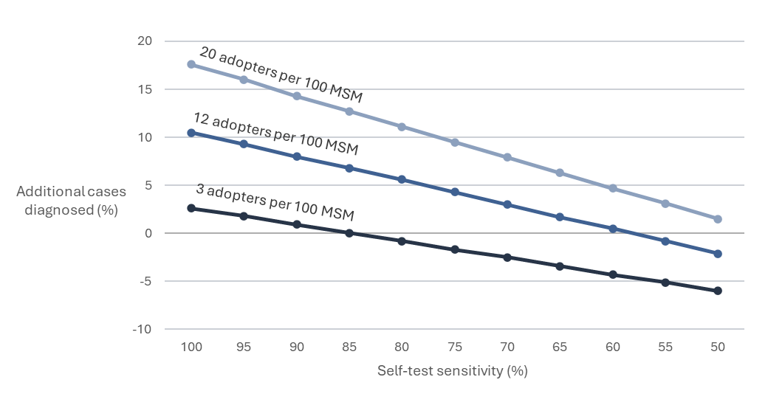

#### Cost analysis

The cost sensitivity analysis aimed to determine the maximum wholesale unit cost of the self-test that would result in either cost savings or cost effectiveness; for all combinations of low, medium and high values for the uptake parameters and test specifications (listed in Table 6 below).

The intervention scenario is considered cost-effective when the cost per additional person correctly diagnosed is less than the cost per person diagnosed under the status quo.

The range of values in Table 6 aim to approximately estimate a 90% confidence interval for each parameter, as far as is possible based on the data available.

It was observed that numbers of switchers and adopters in the same ratio produced both the same savings thresholds and same cost-effectiveness thresholds, therefore only the ratio was varied in sensitivity analysis.

The cost benefit analysis was restricted to parameter combinations that resulted in more diagnoses of current syphilis under the intervention scenario.

### Table 6: Multivariate cost sensitivity analysis

| **Variable parameter** | **Low estimate** | **Medium estimate** | **High estimate** |
| --- | --- | --- | --- |
| Ratio of switchers to adopters | 1 | 4 | 10 |
| Complement rate | 50% | 70% | 90% |
| Adopter LTFU rate | 5% | 10% | 20% |
| Self-test sensitivity | 80% | 90% | 99% |
| Self-test specificity (past infection) | 70% | 85% | 99% |

The analysis results produced a range in cost-saving thresholds from $2.00 to $79.02. The strongest predictors for a low threshold were a high complement rate and a low switcher-to-adopter ratio.

The range of cost-effectiveness thresholds was $21.18 to $124.91. The strongest predictors for a low threshold were a high complement rate and a high switcher-to-adopter ratio.

## References

1. *GBQ+ Community Periodic Surveys | Centre for Social Research in Health - UNSW Sydney.* UNSW Sites.

2. Newham, B., et al. *Implementing Australia's first free national HIV self-testing service - first year successed in attracting high proportions of overseas born, Medicare ineligible, suburban, and regional users*. in *2nd Asia Pacific Conference on Point of Care Testing*. 2025. Bangkok, Thailand.

3. *Home - ACCESS Project*. Available from: <https://accessproject.org.au/>.

4. Park, I.U., et al., *Sensitivity and Specificity of Treponemal-specific Tests for the Diagnosis of Syphilis.* Clinical Infectious Diseases, 2020. **71**(Supplement_1): p. S13-S20.

5. Larsen, S.A., B.M. Steiner, and A.H. Rudolph, *Laboratory diagnosis and interpretation of tests for syphilis.* Clinical Microbiology Reviews, 1995. **8**(1): p. 1-21.

6. Park, I.U., et al., *Performance of Treponemal Tests for the Diagnosis of Syphilis.* Clinical Infectious Diseases, 2019. **68**(6): p. 913-918.

7. Cantor, A., et al., *Introduction*, in *Screening for Syphilis in Nonpregnant Adolescents and Adults: Systematic Review to Update the 2004 U.S. Preventive Services Task Force Recommendation [Internet]*. 2016, Agency for Healthcare Research and Quality (US): Rockville, Maryland.

8. *Syphilis – CDNA National Guidelines for Public Health Units*. 2018, Australian Government Department of Health and Aged Care.

9. Satyaputra, F., et al., *The Laboratory Diagnosis of Syphilis.* Journal of Clinical Microbiology, 2021. **59**(10): p. e00100-21.

10. *Point-of-care tests for sexually transmitted infections: Target product profiles*. 2023, World Health Organisation: Geneva.

11. *MBS Online*. [cited 2025 12 August ]; Available from: <https://www.mbsonline.gov.au/>.