
Burnet Disability Plan 2024-27 Progress Report

Reporting period: June 2024 – June 2025
Prepared by: Diversity, Equity & Inclusion Team

Introduction
Burnet Institute’s disability action plan (DAP) was launched with great success on 25 July 2024, attracting around 200 attendees in-person and online. The event opened with a Welcome to Country from Aunty Janet Galpin of the Boon Wurrung Land and Sea Council, who set an inspiring tone by inviting everyone to "Come with purpose to our beautiful home, land of the 2 days," and reminding us that every contribution, big or small, moves us closer to an inclusive future.
The DAP functions as the implementation plan for Burnet’s Disability Inclusion Policy. It is structured around 3 core pillars: Workplace Culture, Research and Development Work, and Advocacy and Communication. These focus areas guide our actions and help to address the specific cultural contexts in which Burnet operates, particularly in Myanmar and Papua New Guinea (PNG). Since the launch of our DAP, Burnet has also established an office in Vanuatu, and work is underway to address disability inclusion within the team.
In 2024, Burnet’s DAP was recognised by the Department of Foreign Affairs and Trade (DFAT) accreditation team as "the gold standard” and exemplary in highlighting the Institute’s strong commitment to disability inclusion across both operations and program work. Actions in our DAP continue to be implemented in alignment with Australia’s International Disability Equity and Rights Strategy.
The DAP aims to eliminate barriers to participation, promote accessibility, and ensure equitable access to opportunities and resources for all.
The strength of the DAP launch — and the high level of engagement — reflects the hard work and deep collaboration that shaped its development. A diverse stakeholder steering group co-designed the actions within the plan. Importantly, the goal of the DAP is not to complete actions as quickly as possible, but to drive thoughtful, sustainable change. As implementation continues, it is expected — and entirely appropriate — that some actions will require preliminary steps or baseline work. This process of learning, adapting and building strong foundations ensures that outcomes are meaningful and enduring. A focus on sustainable change, leadership by people with lived experience of disability, and a holistic, intersectional approach to disability inclusion continues to guide all activities.
What is particularly encouraging at this early stage is the strong sense of shared ownership across Burnet. Accountability for implementation is not isolated to a few individuals or teams — it is held widely. Most actions are either complete, actively underway, or moving into the active planning stage; not a single one has been left untouched.
The Diversity, Equity and Inclusion (DEI) team has worked closely with stakeholders throughout the process to implement actions and maintain momentum, providing support where needed.
This progress report highlights not only what has been achieved so far, but also the way we are approaching implementation — with intention, collaboration, and care.


Next Steps and Recommendations
1. Strategic focus
After a strong start in the first year, the next phase of the DAP will focus on long-term, sustainable change. Over the next 2 years, Burnet will continue to foster an inclusive environment that supports people with disabilities. This will include efforts to enhance workplace culture, provide ongoing education, refine research practices, and expand advocacy efforts to ensure greater inclusivity.
2. Emphasis on accessible communication
Burnet has made significant progress in understanding accessibility standards for documents and key communication channels, largely driven by the Marketing and Communications team. However, upskilling is needed across the organisation. The goal is to engage staff through training and support to consider accessibility from the outset when developing communication materials so they can contribute to Burnet’s commitment and identify when specialised external support is needed.
3. Disability-inclusive research and GEDSI training
GEDSI (Gender Equality, Disability, and Social Inclusion) training will be a priority for the next 2 years. Regular learning sessions will involve staff and external experts to build knowledge on disability inclusive practices in research and project implementation. These sessions will also contribute to the development of a GEDSI library and shared learning platform.

4. Collaboration and coordination
Effective collaboration across Burnet offices in Australia, PNG, Myanmar, and Vanuatu is essential. GEDSI learning sessions will ensure actions are consistently applied and adapted to local contexts and needs. Regular exchanges about policy and procedural updates across human resources teams are equally important to maintain alignment.

5. Measuring impact and feedback integration
Expanding feedback mechanisms for accessibility challenges, especially in research and recruitment, is key. Partial impact has already been measured, including disability data collected through the DEI survey and employee self service platform. A skills gap analysis will be conducted every 2-3 years to assess progress.

6. Inclusive recruitment and data collection

Expanding inclusive recruitment practices and improving disability-related data collection are critical next steps, including improving the collection of disability data in a sensitive and confidential manner. New training modules are being explored to onboard people managers with knowledge of inclusive environments.

7. Implementation and key priorities
By the end of 2025, Burnet should prioritise:
finalising enhancements to the recruitment cycle, including training for hiring managers
launching tailored disability inclusion training for researchers and project managers
implementing priority intranet accessibility upgrades
expanding success stories
rolling out the Workplace Adjustment Policy
supporting Myanmar and PNG offices in embedding inclusive workplace and research practices; and initiating work in the Vanuatu office.

8. Executive recommendations for action
Invest in capacity building by continuing to allocate resources that allow us to upskill teams, particularly in document accessibility and research inclusion.

Individual action updates
Individual actions related to the DAP highlight progress across the 3 strategic pillars:
Workplace Culture, Research and Development Work, and Advocacy and Communication, along with actions for teams in our PNG and Myanmar offices.

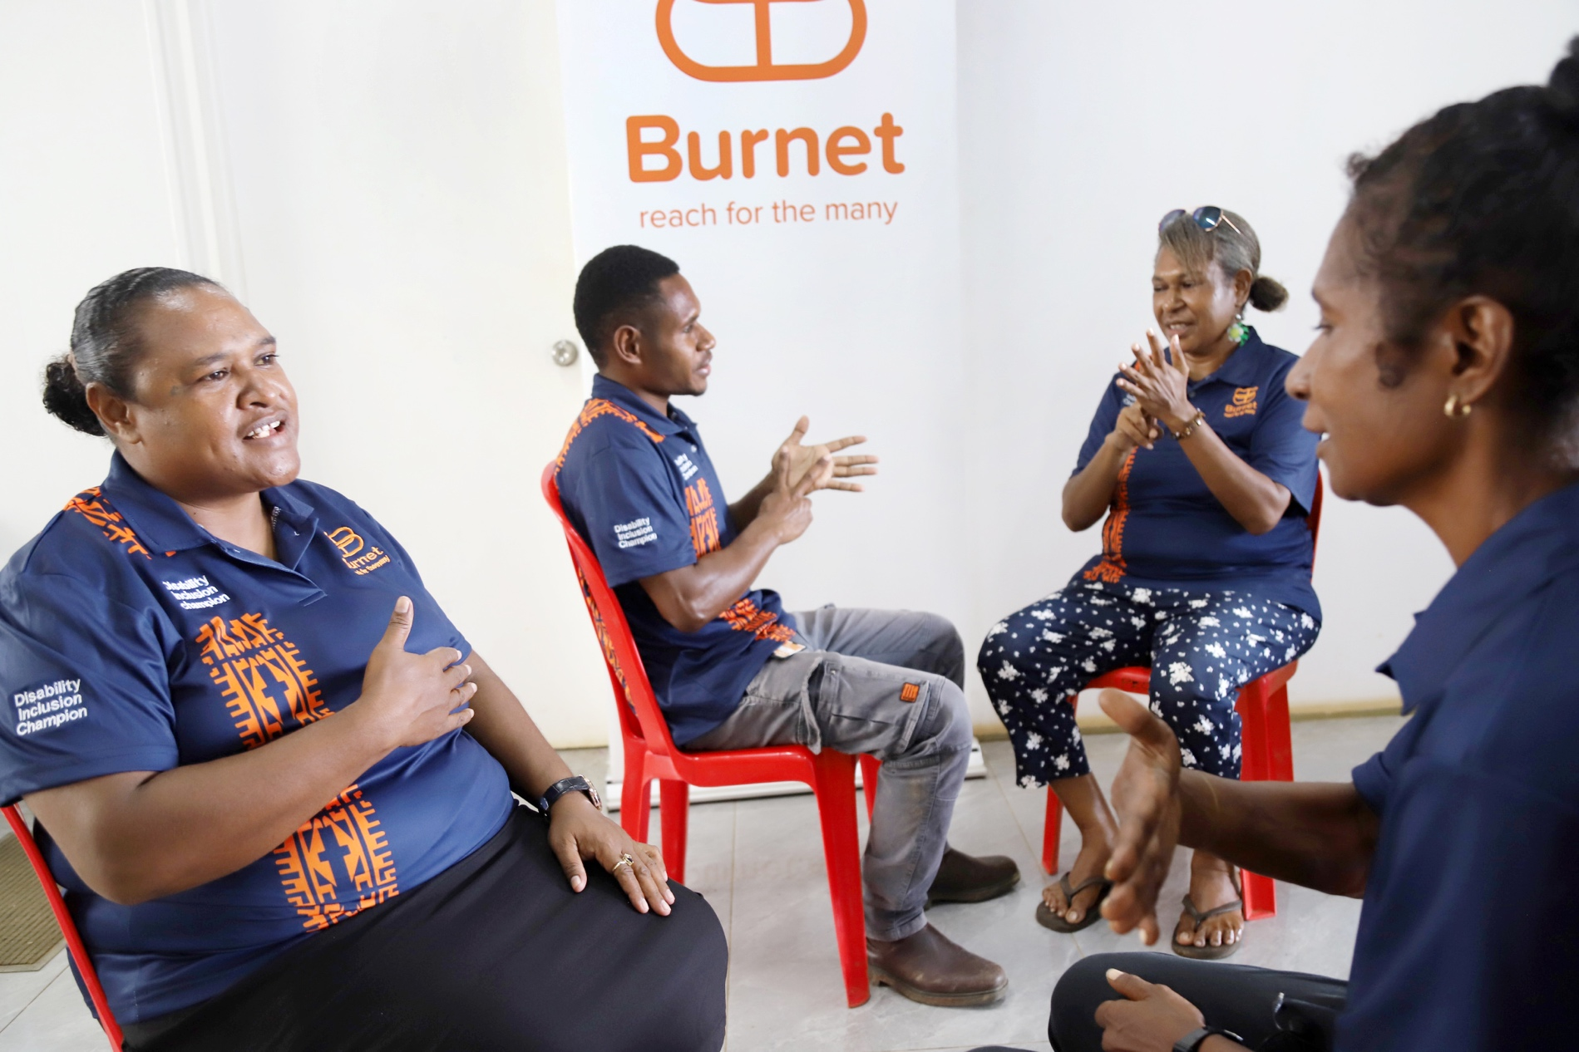
Image: Staff sign language training in Daru, Papua New Guinea, 2024.

Governance and reporting

Action 1.1

Our commitment:
Get formal approval and public support for the DAP from the Executive Committee and the Board.

Accountability:
Deputy Director, Gender Equity, Diversity and Inclusion

Status:
Complete

Progress update:
The DAP has been formally approved by the Executive Committee and the Board.

Action 1.2

Our commitment:
Register the DAP with the Australian Human Rights Commission.

Accountability:
Deputy Director, Gender Equity, Diversity and Inclusion

Status:
Complete

Progress update:
The DAP was registered with the Australian Human Rights Commission in September 2024.

Action 1.3

Our commitment:
Scope the resourcing of the DAP to ensure consistency in implementation and create a dedicated budget.

Accountability:
Chief Operating Officer; Chief of People, Planning and Governance

Status:
Ongoing/recurrent

Progress update:
Each stakeholder has scoped and budgeted for their action — either through their own budget or in collaboration with the DEI team. There is now a process in place to review and plan resourcing annually.

Action 1.4

Our commitment:
Continuously involve key stakeholders in DAP development and implementation.

Accountability:
Deputy Director, Gender Equity, Diversity and Inclusion

Status:
Ongoing/recurrent

Progress update:
A stakeholder steering group has been established and meets 1–2 times per year to support the development and implementation of the DAP. This is the same group that was involved in determining the initial DAP actions.

Action 1.5

Our commitment:
Publish a report detailing our progress in implementing actions from the DAP at least once a year.

Accountability:
Chief of Public Affairs

Status:
Ongoing/recurrent

Progress update:
The DEI team, in collaboration with the Marketing and Communications team, provides an annual progress report on the DAP. Key achievements are also included in the Institute’s end-of-year DEI report.

Action 1.6

Our commitment:
Ensure staff and students are aware of and understand changes to policies, processes and procedures.

Accountability:
Chief of People, Planning and Governance

Status:
Ongoing/recurrent

Progress update:
Updates to related policies are continuously reviewed and communicated. Every policy is developed or updated in consultation with relevant subject matter experts across the Institute. Where significant changes or new policies are introduced, the GEDI Council and employee resource group (ERG) network are consulted during the early stages. Examples include consultations on the Respect@Work Policy, the Remuneration Policy and the Disability Inclusion Policy.

Action 1.7

Our commitment:
Ensure that DAP actions related to research and development work, and advocacy and communication align with Burnet’s quality assurance initiatives.

Accountability:
Head, International Program Quality and Effectiveness

Status:
In progress

Progress update:
The International Program Quality and Effectiveness team, DEI team, and safeguarding manager have worked closely to align manuals, trainings and other resources. Key roles like GEDSI advisor and safeguarding manager have been established since the launch of the DAP.

Action 1.8

Our commitment:
Create an advisory group made up of people with lived experience of disability. Consult regularly with the group on disability inclusive initiatives.

Accountability:
Disability Inclusion Committee

Status:
Ongoing/recurrent

Progress update:
The Disability Inclusion Committee has been restructured as an ERG, serving as the key advisory body for the DAP. It continues to welcome new members with lived experience of disability and actively consults on relevant initiatives.

Action 1.9

Our commitment:
Appoint a person with lived experience of disability as chair of the Disability Inclusion Committee. Increase representation on the committee of members with lived experience of disability.

Accountability:
Diversity and Inclusion Manager

Status:
Complete

Progress update:
The Disability Inclusion Committee is chaired by a member with lived experience of disability. Budget has been allocated to support the committee chair to upskill through a course with the Disability Leadership Institute.

Action 1.10

Our commitment:
Develop a forum or channel for those with lived experience of disability to share their experiences and help shape Burnet’s disability and inclusion progress.

Accountability:
Disability Inclusion Committee

Status:
In progress

Progress update:
As noted in Action 1.8, the Disability Inclusion Committee operates under the ERG framework and offers a welcoming space for people with lived experience of disability to participate. The committee provides input and advice on policies, procedures, and inclusion initiatives across the Institute, and serves as the advocacy mechanism for people with lived experience of disability.

Burnet Disability Plan targets in Pillar 1: Workplace Culture

Action 2.1

Our commitment:
Establish a method to monitor the Board’s diversity, including disability representation.

Accountability:
Board Chair

Status:
In progress

Progress update:
Work is underway to consider a method for monitoring the Board’s diversity including disability representation

Action 2.2

Our commitment:
Request regular and comprehensive reporting on the progress of the DAP.

Accountability:
Board Chair

Status:
Ongoing/recurrent

Progress update:
An annual progress report, along with regular DAP updates, is shared through various channels and provided to the Board on an ongoing basis.

Action 2.3

Our commitment:
Establish a method for monitoring the Executive Committee’s diversity, including disability representation.

Accountability:
Chief Executive Officer

Status:
In progress

Progress update:
Work is underway to develop a method for monitoring the Executive Committee’s diversity including disability representation.

Action 2.4

Our commitment:
Establish a definition of diversity that serves as the basis for Burnet’s Disability Inclusion Strategy.

Accountability:
Deputy Director, Gender Equity, Diversity and Inclusion

Status:
Complete

Progress update:
A comprehensive definition of diversity, aligned with the Burnet 2030 Strategy, has been developed and endorsed by the Executive Committee.

Action 2.5

Our commitment:
Review practices, policies, and governance in relation to disability inclusion.

Accountability:
Chief Operating Officer

Status:
Ongoing/recurrent

Progress update:
Disability inclusion is now considered as part of the policy and governance practice review and renewal process. This ensures alignment with Burnet’s inclusion goals and best practice principles.

Action 2.6

Our commitment:
Review the current Disability Inclusion Policy and ensure it aligns with Burnet’s Gender Equality Policy.

Accountability:
Chief of People, Planning and Governance

Status:
Complete

Progress update:
The Disability Inclusion Policy has been reviewed to align with the Gender Equality Policy. It was formally approved by the Executive Committee in July 2025.

Action 2.7

Our commitment:
Establish mechanisms to measure and report on the impact of commitments outlined in the DAP.

Accountability:
Head, International Program Quality and Effectiveness

Status:
In progress

Progress update:
A bi-annual DEI survey now includes key questions that help to measure the impact of commitments outlined in the DAP.

Action 2.8

Our commitment:
Assess the need for a new role at the Institute to support gender equality, diversity, and social inclusion in research and development work.

Accountability:
Chief of People, Planning and Governance

Status:
Complete

Progress update:
A permanent GEDSI advisor role was established in September 2024. The role functions within the DEI team and is part of the People team.

Action 2.9

Our commitment:
Research and identify best practices to integrate accessibility and universal design as mandatory criteria for products and services in our Procurement Policy.

Accountability:
Chief Financial Officer

Status:
In progress

Progress update:
Work is underway to identify best practices for integrating accessibility and universal design into procurement processes and future policy updates.

Action 2.10

Our commitment:
Establish and disseminate a list of preferred suppliers who meet desired accessibility, universal design, and recruitment standards.

Accountability:
Chief Financial Officer

Status:
Ongoing/recurrent

Progress update:
A list of preferred suppliers has been developed by the Disability Inclusion Committee and the Business Services team.

Action 2.11

Our commitment:
Develop mechanisms within the procurement process to
gather staff feedback on accessibility challenges. Use this feedback to inform future policies and purchasing practices.

Accountability:
Chief Financial Officer

Status:
In progress

Progress update:
Work is underway to explore methods of collecting staff feedback on accessibility challenges to help shape future procurement practices.

Action 2.12

Our commitment:
Evaluate accessibility of online recruitment platforms to identify possible improvements.

Accountability:
Talent Acquisition Lead

Status:
Complete

Progress update:
An evaluation of online platforms used for application, interviewing, and onboarding has been reviewed, and areas for improvement have been identified.

Action 2.13

Our commitment:
Assess the candidate experience and create a list of best-practice recommendations to assist at every phase of the recruitment cycle, including advertising, screening, interviewing, assessing, and selecting.

Accountability:
Talent Acquisition Lead

Status:
In progress

Progress update:
The candidate experience has been assessed, and a list of best-practice recommendations has been developed to support accessibility across all recruitment phases.

Action 2.14

Our commitment:
Complete the Australian Disability Network’s Confident Recruitment modules. Review steps involved to achieve Disability Confident Recruiter organisational status.

Accountability:
Talent Acquisition Lead

Status:
Complete

Progress update:
The talent acquisition lead has completed the Australian Disability Network’s Confident Recruitment modules and reviewed the steps required to achieve Disability Confident Recruiter status.

Action 2.15

Our commitment:
Collect more comprehensive candidate data on disability to inform future actions.

Accountability:
Talent Acquisition Lead

Status:
Complete

Progress update:
Disability-related questions have been integrated into the application process and recruitment surveys, improving the collection of candidate data to inform future actions and monitor bias.

Action 2.16

Our commitment:
Develop a formal commitment to include staff with disability in career development and retention strategies.

Accountability:
Chief of People, Planning and Governance

Status:
In progress

Progress update:
Several staff members are scheduled to take part in a development course in 2025 that is designed to give them what they need to use their disability as an asset as they grow their understanding of how to operate as a leader.

Action 2.17

Our commitment:
Ensure leaders and managers understand and support their staff to:
evaluate roles to better accommodate people with disability
consider people’s needs
facilitate workplace adjustments, promote staff support programs and other resources
promote disability inclusion learning opportunities.

Accountability:
Chief of People, Planning and Governance

Status:
Ongoing/recurrent

Progress update:
Under the Institute’s Leadership Capability Framework, the first DEI upskilling opportunity — a series of workshops designed to equip leaders to support neurodivergent team members — was delivered by a person with lived experience of disability in July 2025. This is an initial step to build leadership capability in disability inclusion.

Action 2.18

Our commitment:
Negotiate funding to support internship programs and mentoring opportunities for students and jobseekers with disability.

Accountability:
Chief of People, Planning and Governance

Status:
Early planning

Progress update:
Work is underway to strengthen our supportive and inclusive culture, which will serve as a foundation for future internship and mentoring initiatives.

Action 2.19

Our commitment:
Review and implement guidelines to ensure learning and development programs and activities are accessible, including online and written materials and workshops.

Accountability:
Chief of People, Planning and Governance

Status:
In progress

Progress update:
Guidelines for accessible learning and development programs are being considered. This work is being undertaken in collaboration with the Marketing and Communications team.

Action 2.20

Our commitment:
Review current professional development awards to improve opportunities for people with disability.

Accountability:
Chief of People, Planning and Governance

Status:
In progress

Progress update:
A review of professional development awards to identify opportunities for people with disability is under consideration.

Action 2.21

Our commitment:
Develop, seek approval for, and implement a workplace adjustment policy and procedure.

Accountability:
Head, Laboratories and Facilities; Manager, OHS and Compliance

Status:
In progress

Progress update:
A workplace adjustment policy and procedure are being developed by the OHS and Compliance team in collaboration with the People team.

Action 2.22

Our commitment:
Become acquainted with JobAccess and its services, determine the benefits for Burnet and proactively share this knowledge as appropriate.

Accountability:
Diversity and Inclusion Manager

Status:
In progress

Progress update:
A review of JobAccess services is underway.

Action 2.23

Our commitment:
Create simple resources and tools to help staff and managers talk about adjustments that might be needed at work.

Accountability:
Head, OHS and Compliance

Status:
In progress

Progress update:
Plans are underway to make resources available on the staff intranet.

Action 2.24

Our commitment:
Develop a feedback mechanism, including de-identified options, for staff to share their experiences on requesting and accessing workplace adjustments.

Accountability:
Chief of People, Planning and Governance

Status:
In progress

Progress update:
A feedback mechanism is being developed with a focus on ensuring staff can share their experiences safely and anonymously.

Action 2.25

Our commitment:
Create a user-friendly page on the staff intranet to provide dedicated information and resources for people with disability and their managers. This content will cover the diverse aspects of disability inclusion in our work and research and include success stories demonstrating our advancements in this space.

Accountability:
Diversity and Inclusion Manager

Status:
In progress

Progress update:
A dedicated intranet page is being considered. Resources will be added over time, including a neurodiversity toolkit for people managers.

Action 2.26

Our commitment:
Share success stories and case studies of staff who have benefited from workplace adjustments.

Accountability:
Head, OHS and Compliance

Status:
Ongoing/recurrent

Progress update:
A plan is being developed to share success stories and case studies of staff who have benefited from workplace adjustments.

Action 2.27

Our commitment:
Audit all work sites for accessibility and commit to remediation.

Accountability:
Head, Laboratories and Facilities; Manager, OHS and Compliance

Status:
In progress

Progress update:
Accessibility considerations have been included in refurbishment planning for the Burnet Melbourne office. Internal discussions about applying accessibility checklists are ongoing.

Action 2.28

Our commitment:
Ensure concerns regarding accessibility for facilities are being considered in the building plans and equipment for the new Australian Institute for Infectious Disease (AIID).

Accountability:
Head, Laboratories and Facilities

Status:
In progress

Progress update:
Extensive work and planning have gone into embedding accessibility considerations into the AIID building design. Ongoing discussions are addressing a wide range of universal design features — including adjustable laboratory benches, adaptable lighting, ramps, sound insulation, and other inclusive infrastructure elements — to ensure the space is both welcoming and functional.

Action 2.29

Our commitment:
Include a Personal Emergency Evacuation Plan (PEEP) in standard induction packs for new staff as part of the onboarding process.

Accountability:
Manager, OHS and Compliance

Status:
Complete

Progress update:
A Personal Emergency Evacuation Plan (PEEP) has been formally incorporated into the standard induction process for new staff, strengthening Burnet’s approach to emergency preparedness and inclusion.

Action 2.30

Our commitment:
Collaborate with emergency wardens to ensure they understand their responsibilities regarding the PEEP.

Accountability:
Manager, OHS and Compliance

Status:
In progress

Progress update:
Training for emergency wardens, including the integration of the PEEP, is planned.

Action 2.31

Our commitment:
Set up a clear stage-based consultation process that defines roles as a vital part of our physical environment adjustments.

Accountability:
Head, OHS and Compliance

Status:
In progress

Progress update:
Our consultation procedure is under review to provide clearer guidance on engaging staff and students with the provisions of the Occupational Health and Safety Act 2004. This takes disability into consideration where relevant.

Action 2.32

Our commitment:
Review existing industry standards and training for information technology (IT) on disability inclusion and determine appropriate adjustments.

Accountability:
Chief Technology Officer

Status:
Ongoing/recurrent

Progress update:
Scoping for possible training modules is underway.

Action 2.33

Our commitment:
Assess existing IT software.

Accountability:
Chief Technology Officer

Status:
In progress

Progress update:
A quick guide to Microsoft 365 tools which is being developed for the staff intranet. Further assessments of additional systems are planned.

Action 2.34

Our commitment:
Incorporate a process for evaluating disability inclusion when acquiring new software.

Accountability:
Chief Technology Officer

Status:
In progress

Progress update:
A checklist for disability inclusion is being developed and will be incorporated in the induction process for members of the IT team.

Action 2.35

Our commitment:
Publish key information about disability inclusion and software, including a method for people to request support or share feedback.

Accountability:
Chief Technology Officer

Status:
In progress

Progress update:
A survey is being developed to gather staff feedback after the implementation of a new system.

Action 2.36

Our commitment:
Develop and implement an inclusive language guide, making it a key component of the revision of Burnet's existing communication guidelines.

Accountability:
Chief of Public Affairs

Status:
In progress

Progress update:
A steering group has been established to support the development and implementation of the guide.

Action 2.37

Our commitment:
Conduct an accessibility review of the Burnet website.

Accountability:
Chief of Public Affairs

Status:
In progress

Progress update:
An accessibility audit of the Burnet website is complete, and subsequent actions have been implemented. Next steps include adding a statement on both the staff intranet and website with an email address for users to request accessible versions of content.

Action 2.38

Our commitment:
Conduct an inclusive language audit of the Burnet website, including plain language, to identify areas for improvement.

Accountability:
Chief of Public Affairs

Status:
Complete

Progress update:
An inclusive language audit of the Burnet website is complete with recommended changes now reflected. Work is underway to develop and implement an inclusive language guide for the Institute (refer Action 2.36).

Action 2.39

Our commitment:
Incorporate alt text in all social media posts containing images.

Accountability:
Chief of Public Affairs

Status:
Complete

Progress update:
Alt text is now included in all social media posts containing images.

Action 2.40

Our commitment:
Incorporate closed captions in the development of videos where appropriate.

Accountability:
Chief of Public Affairs

Status:
Complete

Progress update:
Closed captions are now considered as part of the creation and publishing of videos where appropriate.

Action 2.41

Our commitment:
Maintain the use of accessible visual treatments for external and internal communication in line with Burnet’s Brand Guidelines.

Accountability:
Chief of Public Affairs

Status:
Complete

Progress update:
Brand guidelines have been updated to align with accessibility best practices. Accessible templates have been created for staff use, key corporate documents are now developed and made available in accessible formats, and creative suppliers have been trained in accessible document design. The Burnet brand now incorporates a digital-specific colour palette and visual elements to provide a more impactful and inclusive experience across key communication platforms.

Action 2.42

Our commitment:
Establish an efficient process for gathering information about students’ adjustment needs and any necessary support before their start date.

Accountability:
Chair, Education and Research Integrity

Status:
In progress

Progress update:
Work is underway to explore how to best gather information on student adjustment needs before their start date.

Action 2.43

Our commitment:
Develop a welcome kit for new students that considers disability inclusion.

Accountability:
Chair, Education and Research Integrity

Status:
In progress

Progress update:
A disability-inclusive welcome kit for students is being developed.

Action 2.44

Our commitment:
Create a comprehensive resource outlining how to best support students with disability.

Accountability:
Chair, Education and Research Integrity

Status:
In progress

Progress update:
Scoping has begun to develop of a resource that will inform support for students with disability.

Action 2.45

Our commitment:
Develop comprehensive academic adjustment plan guidelines, incorporating specific eligibility criteria for students.

Accountability:
Chair, Education and Research Integrity

Status:
In progress

Progress update:
Academic adjustment plan guidelines are being developed, including potential eligibility criteria.

Action 2.46

Our commitment:
Assess our curriculum and processes to generate a list of enhancements that will strengthen support systems for students throughout their academic journey.

Accountability:
Chair, Education and Research Integrity

Status:
In progress

Progress update:
Work is underway to consider how curriculum and assessment processes can better support students with disability.

Burnet Disability Plan targets in Pillar 2: Research and Development Work

Action 3.1

Our commitment:
Formalise a commitment to the design and delivery of accessible, inclusive research projects and development work.

Accountability:
Discipline heads

Status:
Early planning

Progress update:
An initial draft outlining Burnet’s commitment to accessible and inclusive research and development work is being prepared by the GEDSI advisor.

Action 3.2

Our commitment:
Conduct a staff needs assessment that considers the Australian Council for International Development (ACFID), Department of Foreign Affairs and Trade (DFAT), and National Health and Medical Research Council (NHMRC) criteria, as well as challenges related to integrating disability. Identify tools, resources, funding and training requirements for disability inclusion in research and development work.

Accountability:
Discipline heads

Status:
In progress

Progress update:
The International Development discipline is under review and a GEDSI gap analysis, led by the GEDSI advisor, is underway. This includes conducting a survey and qualitative interviews to identify challenges and opportunities to strengthen disability inclusion in research and development work.

Action 3.3

Our commitment:
Develop a training program addressing staff needs and identifying barriers to integrating disability.

Accountability:
Discipline heads

Status:
In progress

Progress update:
Initial solutions have been implemented — including staff participation in the ACFID Disability Equity Peer Learning Program and other relevant training — and more structured training has been planned. The training program will be developed following the completion of the GEDSI gap analysis and the creation of an action plan. Additionally, a resource library is being developed to support ongoing learning and implementation of inclusive practices.

Action 3.4

Our commitment:
Identify and/or develop appropriate disability-inclusive research tools and frameworks that align with ACFID, DFAT and NHMRC standards.

Accountability:
Discipline heads

Status:
In progress

Progress update:
Provisional tools and approaches are being explored on a case-by-case basis. The Program and Quality Standards Manual and Project Management Handbook have been finalised and aligned with ACFID, DFAT and NHMRC requirements and standards. A more systematic strategy for identifying or developing specific disability-inclusive research tools and frameworks will be determined following the completion of the GEDSI gap analysis.

Action 3.5

Our commitment:
Develop guidance on disability-inclusive data collection, including the Washington Group (WG) questions and other major methodologies.

Accountability:
Discipline heads

Status:
In progress

Progress update:
The DEI team and International Program Quality team have reviewed the Program and Quality Standards Manual and are developing the Monitoring Evaluation and Learning (MEL) guidelines, which will detail how disability-inclusive data collection — such as the WG questions — can be used.

Action 3.6

Our commitment:
Undertake a review of the detailed international development manual encompassing fieldwork activities. Facilitate a collaborative co-design process that welcomes input from people with disability and staff in relevant fields.

Accountability:
Discipline heads, International Development

Status:
Complete

Progress update:
The International Program Quality team has completed a comprehensive review of the Program Quality and Standards Manual and Project Management Handbook, which includes requirements and best practice guidance for the project design process.

Action 3.7

Our commitment:
Create a centralised repository for storing local, contextual information about disability inclusion and relevant organisations from countries where Burnet operates.

Accountability:
Discipline heads

Status:
In progress

Progress update:
Content is currently being considered and developed, with a plan to publish it on the staff intranet.

Action 3.8

Our commitment:
Conduct a basic scoping exercise to identify existing resources, guidelines and training relating to disability inclusion in life sciences research.

Accountability:
Discipline heads, Life Sciences

Status:
In progress

Progress update:
Initial scoping activities are being scheduled to help identify relevant resources and opportunities that will strengthen disability inclusion in life sciences research.

Burnet Disability Plan targets in Pillar 3: Advocacy and Communication

Action 4.1

Our commitment:
Develop internal strategies for disability-related awareness campaigns, including promoting the work of disability-related programs and projects.

Accountability:
Chief of Public Affairs

Status:
In progress

Progress update:
This work is being carried out in collaboration with the DEI team. In 2024, Burnet formally acknowledged the International Day of People with Disability (IDPwD) for the first time, and R U OK?Day was marked with a focus on mental health support. Moving forward, 2-4 key awareness days will be acknowledged each year. As resources and policies are developed or reviewed, corresponding communication plans are being developed to support broader awareness and engagement.

Action 4.2

Our commitment:
Integrate disability inclusion into existing risk management templates for project and research work.

Accountability:
International Program Quality team

Status:
In progress

Progress update:
The safeguarding manager, GEDSI advisor, and the International Program Quality team are working closely to ensure disability inclusion is meaningfully embedded in project and research risk management processes. Our project operational risk assessment template has been updated to include disability as it relates to programming and social risks. Staff information sessions were held in June 2025, with further training and guidance planned as part of the rollout of other resources.

Action 4.3

Our commitment:
Share stories and successes from our work relating to disability inclusion with internal and external audiences.

Accountability:
Chief of Public Affairs

Status:
In progress

Progress update:
Plans are underway to develop a clear process for staff to share disability inclusion-related success stories with the Marketing and Communications team for broader promotion. This will help enhance the visibility of our efforts. As an initial step, Burnet acknowledged IDPwD in 2024 across internal and external communication channels, amplifying a staff success story.

Action 4.4

Our commitment:
Establish a map of partnership networks with disability inclusion organisations across Australia, Myanmar, PNG, and other locations where we operate.

Accountability:
Director, Funding Partnerships

Status:
Complete

Progress update:
A mapping exercise has been completed and is being incorporated as part of GEDSI resources on the staff intranet.

Action 4.5

Our commitment:
Identify and share funding opportunities that support mainstreaming disability inclusion into broader initiatives or specifically benefit people with disability.

Accountability:
Chief of Funding Growth

Status:
Early planning

Progress update:
A process is being developed to identify relevant funding opportunities.

Burnet Myanmar targets

Action 5.1

Our commitment:
Explore comparable actions for Burnet Myanmar to those already listed under ‘Workplace Culture’ (Actions 2.1 to 2.46).

Accountability:
Country Representative, Myanmar

Status:
In progress

Progress update:
Work is underway to adapt and implement actions locally. Recruiter confidence training was completed by the senior HR and administration manager, and opportunities have been identified to improve recruitment processes.

Action 5.2

Our commitment:
Recruit a disability inclusion position for Burnet Myanmar

Accountability:
Country Representative, Myanmar

Status:
In progress

Progress update:
As an initial step, responsibilities are being shared across several roles. This ensures that disability inclusion considerations are integrated into both organisational and project-level work and will help to assess specific requirements for a dedicated position.

Action 5.3

Our commitment:
Identify training needs and develop a training plan that begins with integrating inclusive language in the workplace.

Accountability:
Country Representative, Myanmar

Status:
In progress

Progress update:
Training needs are being identified, and members of the Myanmar team have joined the steering group responsible for guiding the development and implementation of an inclusive language guide (refer Action 2.36).

Action 5.4

Our commitment:
Ensure existing and new staff members receive and comply with disability inclusion training.

Accountability:
Country Representative, Myanmar

Status:
In progress

Progress update:
The Myanmar team participated in a 3-day disability inclusion training course in December 2024. Partner organisations and people with lived experience of disability were also invited to take part. Further planning is underway to integrate disability inclusion training into onboarding processes and other staff development.

Action 5.5

Our commitment:
Audit work sites for accessibility and commit to remediation, including workplace adjustments for staff and stakeholders.

Accountability:
HR Manager, Myanmar

Status:
Complete

Progress update:
A 2-day accessibility audit of Burnet premises in Myanmar was completed in June 2025. This included an on-site assessment of the workplace, and an analysis of the findings. This was a key step toward identifying barriers and planning for necessary workplace adjustments. Next steps include reviewing the audit report with relevant stakeholders and developing a remediation plan.

Action 5.6

Our commitment:
Establish a staff voice committee to facilitate consistent communication with disability inclusion groups across the organisation.

Accountability:
Country Representative, Myanmar

Status:
In progress

Progress update:
A staff voice committee is being established and further consultation with key stakeholders is planned.

Action 5.7

Our commitment:
Develop inclusive project design frameworks.

Accountability:
Country Representative, Myanmar

Status:
In progress

Progress update:
The team has successfully co-designed frameworks with people with lived experience of disability and engaged extensively with the community. Animation videos are being developed to share learnings and support other teams and future projects in adopting inclusive design approaches.

Action 5.8

Our commitment:
Develop inclusive data collection protocols, including the WG questions.

Accountability:
Country Representative, Myanmar

Status:
In progress

Progress update:
Inclusive data collection protocols are being developed. The team has worked closely with people with lived experience of disability to ensure protocols are appropriate and effective. Educational materials and videos showcasing this inclusive approach are also being developed to support knowledge sharing across all projects.

Action 5.9

Our commitment:
Identify training needs and develop a training plan for disability inclusion.

Accountability:
Country Representative, Myanmar

Status:
In progress

Progress update:
Baseline disability inclusion training has been provided to the Myanmar team. Further consideration and planning are underway to develop a comprehensive, ongoing training plan that will help to enhance staff knowledge and skills in this area.

Action 5.10

Our commitment:
Develop and deliver a diversity and inclusion toolkit.

Accountability:
Research Director, Myanmar

Status:
In progress

Progress update:
Animation videos are being developed as a part of the toolkit. These resources will support effective delivery and uptake of diversity and inclusion principles across teams.

Action 5.11

Our commitment:
Build in project feedback mechanisms that include questions on disability and accessibility.

Accountability:
Country Representative, Myanmar

Status:
Early planning

Progress update:
Feedback tools that address disability and accessibility are being explored.

Action 5.12

Our commitment:
Use Burnet’s central repository (refer Action 3.7) to store country-specific data, including disability training resources and information about local disability organisations.

Accountability:
Country Representative, Myanmar


Status:
In progress

Progress update:
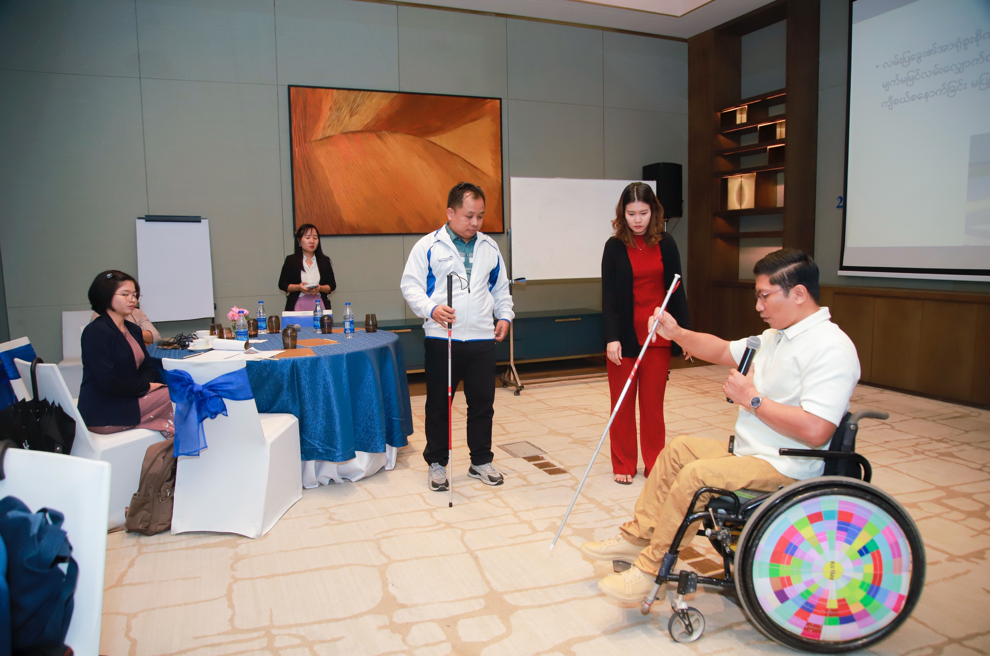
A process for storing and sharing country-specific data and disability training resources on the staff intranet is being developed.
Image: Myanmar staff disability training, December 2024.

Burnet PNG targets

Action 6.1

Our commitment:
Recruit a dedicated disability inclusion position for the Burnet PNG office.

Accountability:
Country Director, PNG

Status:
In progress

Progress update:
A more suitable course of action has been determined and includes nominating staff from each office in PNG to be disability inclusion champions. These champions will help lead the implementation of disability inclusion actions, and provide feedback on challenges, barriers, and successes.

Action 6.2

Our commitment:
Identify training needs and create a training strategy which incorporates inclusive language in the workplace and considers language variations between provinces.

Accountability:
Country Director, PNG

Status:
In progress

Progress update:
Training needs are being identified, and members of the PNG team have joined the steering group responsible for guiding the development and implementation of an inclusive language guide (refer Action 2.36).

Action 6.3

Our commitment:
Audit work sites for accessibility and commit to remediation, including workplace adjustments.

Accountability:
Country Director, PNG

Status:
In progress

Progress update:
An accessibility audit has been completed across all Burnet premises in PNG has been completed. As part of the remediation, ramps are being constructed. Careful consideration is being given to ramp design to ensure they are not too steep and that durable materials are used to support long-lasting accessibility improvements.

Action 6.4

Our commitment:
Identify accessible training and conference locations and establish partnerships with relevant venues.

Accountability:
Country Director, PNG

Status:
Complete

Progress update:
Safe and appropriate accessible training and conference locations have been identified, and agreements with these venues have been established.

Action 6.5

Our commitment:
Establish PNG representation in Burnet’s Disability Inclusion Committee.

Accountability:
Country Director, PNG

Status:
In progress

Progress update:
Work is underway to establish PNG representation in the committee as well as a local committee equivalent in country.

Action 6.6

Our commitment:
Develop inclusive project design frameworks.

Accountability:
Country Director, PNG

Status:
In progress

Progress update:
A regular GEDSI PNG meeting has been established, with the GEDSI advisor from the Melbourne office participating. Mechanisms have been developed to support inclusive project design and further planning is underway to enhance outcomes.

Action 6.7

Our commitment:
Develop inclusive, accessible data collection protocols, including the WG questions, for all projects in PNG.

Accountability:
Country Director, PNG

Status:
In progress

Progress update:
Initial discussions have taken place to progress inclusive and accessible data collection work and develop a more consistent approach across all projects.

Action 6.8

Our commitment:
Identify training needs and develop a training plan to ensure new and existing staff participate in disability inclusion training.

Accountability:
Country Director, PNG

Status:
In progress

Progress update:
GEDSI advisors are participating in disability inclusion training offered by ACFID. Initial discussions are underway to explore the development of onboarding modules and a broader training plan to support new and existing staff.

Action 6.9

Our commitment:
Develop a diversity and inclusion toolkit with Disabled People’s Organisations Australia (DPO Australia).

Accountability:
Country Director, PNG

Status:
Early planning

Progress update:
Work is underway to explore the development of a diversity and inclusion toolkit in collaboration with DPO Australia. Engagement and consultation will be required to ensure the toolkit is contextually relevant and grounded in lived experience of disability.

Action 6.10

Our commitment:
Build in project feedback mechanisms that include questions about disability and accessibility.

Accountability:
Country Director, PNG

Status:
Early planning

Progress update:
Mechanisms are being developed with questions on disability and accessibility. Further work is planned to adapt these tools for a PNG context and ensure meaningful input is captured and used effectively.
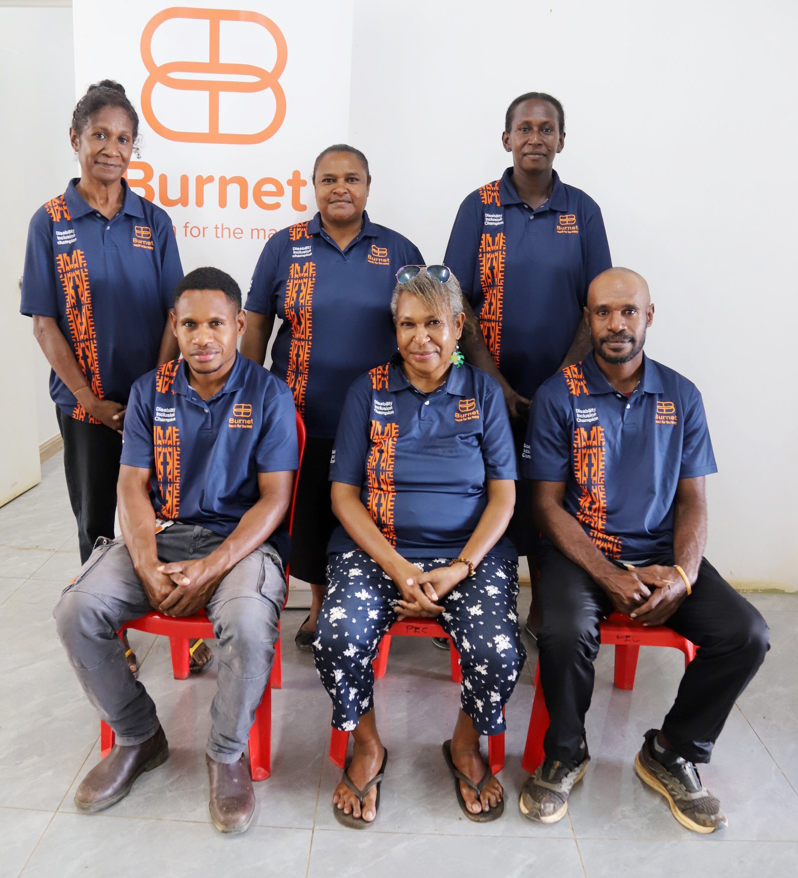
Image: Members of the Western Province disability champions group.


Staff testimonials

Tim Edwards

Digital Experience Manager

Action 2.37: Conduct an accessibility review of the Burnet website.
“Burnet advances health equity by reaching people at greater risk of poor health outcomes. These same people often face barriers to accessing the internet, navigating websites or understanding medical information. Improving digital accessibility can help them.
Websites and the internet are sources of critical information. An inaccessible website is like a bad library. This library also has critical information in it, but it has no wheelchair access ramp, the doors to some of the rooms are locked, the books are on the wrong shelves and the microfiche reader is broken. The important point is that if these barriers are removed the library becomes more useful for everyone – not just people with disability.”
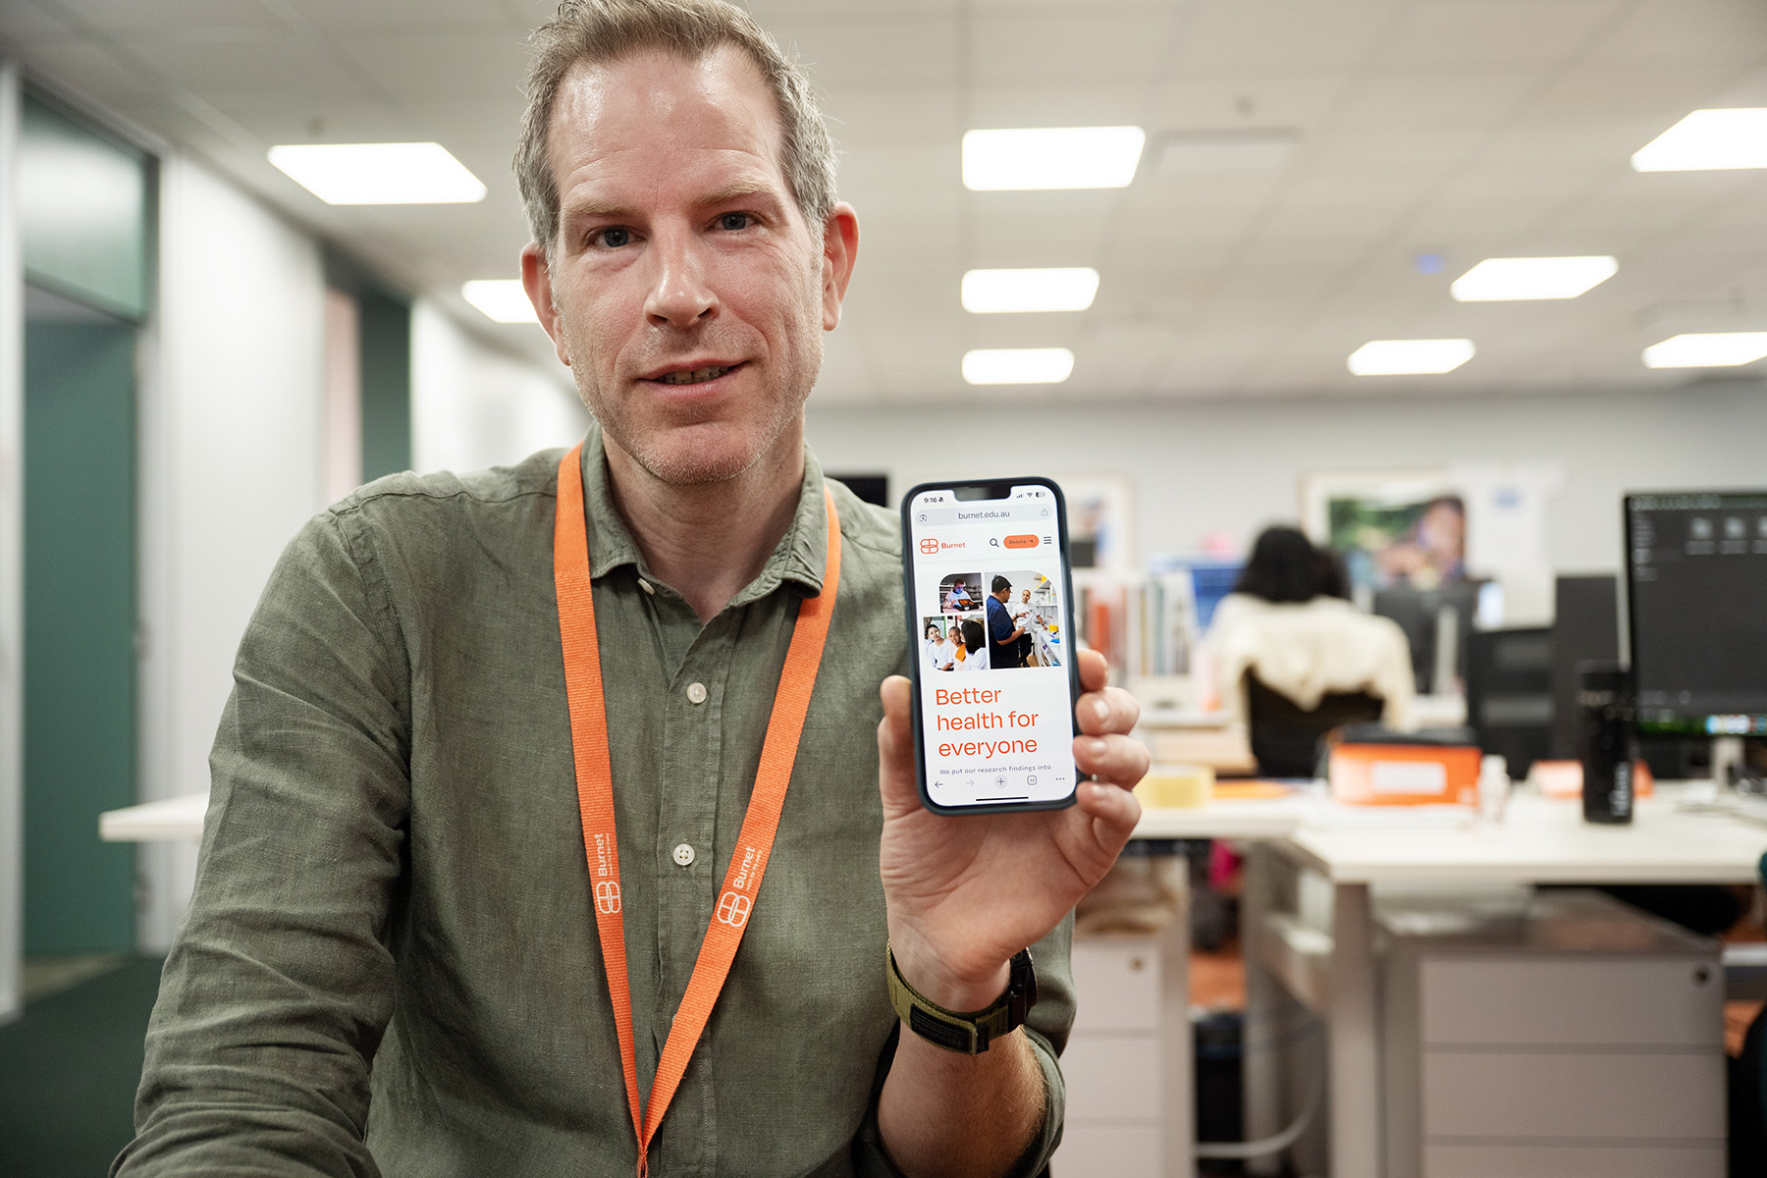
Image: Tim Edwards reviews the Burnet website to improve digital accessibility.

Lulu Mason

Brand and Creative Services Manager

Action 2.41: Maintain the use of accessible visual treatments for external and internal communication in line with Burnet's Brand Guidelines.
“I believe accessibility is more than a design principle — it’s a reflection of our commitment to social justice and equality. We have embedded accessibility into every layer of our creative practice. We’ve updated our brand guidelines to align with accessibility best practices and created adaptable, accessible branded templates – moving away from less inclusive platforms. Key corporate documents have been designed with accessibility at their core. We’ve also trained our creative suppliers to create accessible materials.

While we have made significant progress in educating staff and integrating accessibility into our brand and communications, we recognise our understanding of accessibility is ongoing and there is always more to be done.”
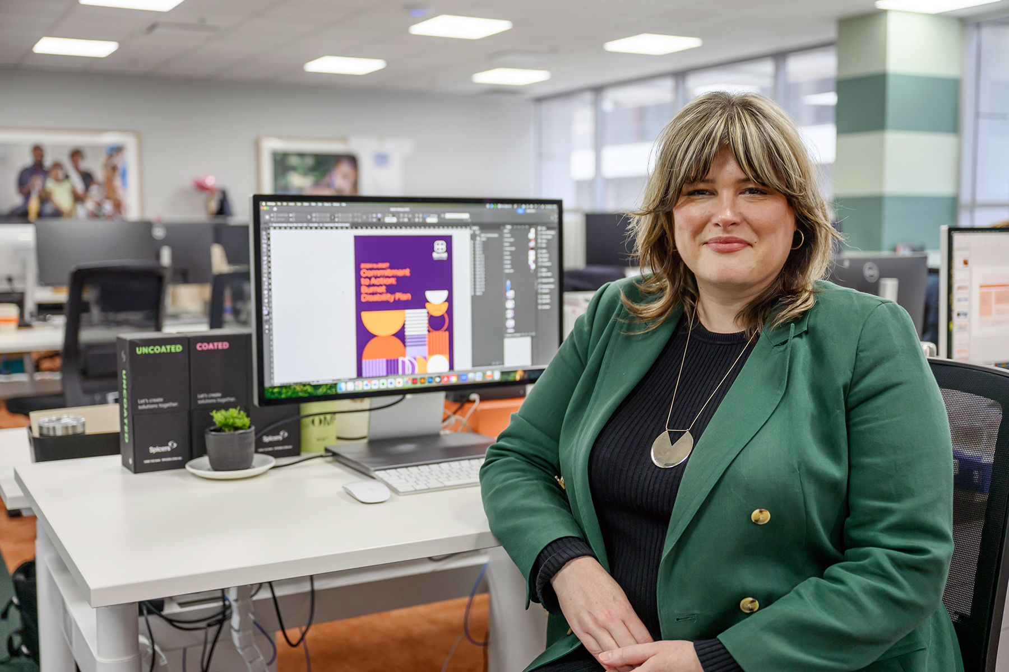
Image: Lulu Mason working on the Disability Action Plan using accessible design methods.

Dr Margarete White

Head, OHS and Compliance

Dr Annabel Teusner

Manager, OHS and Compliance

Action 2.23: Provide concise resources and tools for staff and managers to guide discussions about required adjustments

“We also aim to go beyond compliance, striving for best practice wherever possible. Burnet’s Reasonable Workplace Adjustments policy and procedure is designed to help meet our obligations to people with disability under the Disability Discrimination Act. Formalising these processes through the DAP has been critical. It ensures that all staff can participate safely and fully in the workplace, regardless of disability. Measures such as accessible infrastructure, flexible work arrangements, and tailored supports enable staff to thrive.
Our next steps include finalising and implementing the Workplace Adjustments policy, commencing Personal Emergency Evacuation Procedures (PEEP) training for wardens, expand the use of accessibility checklists in infrastructure projects, and publish staff success stories to normalise workplace adjustments.”
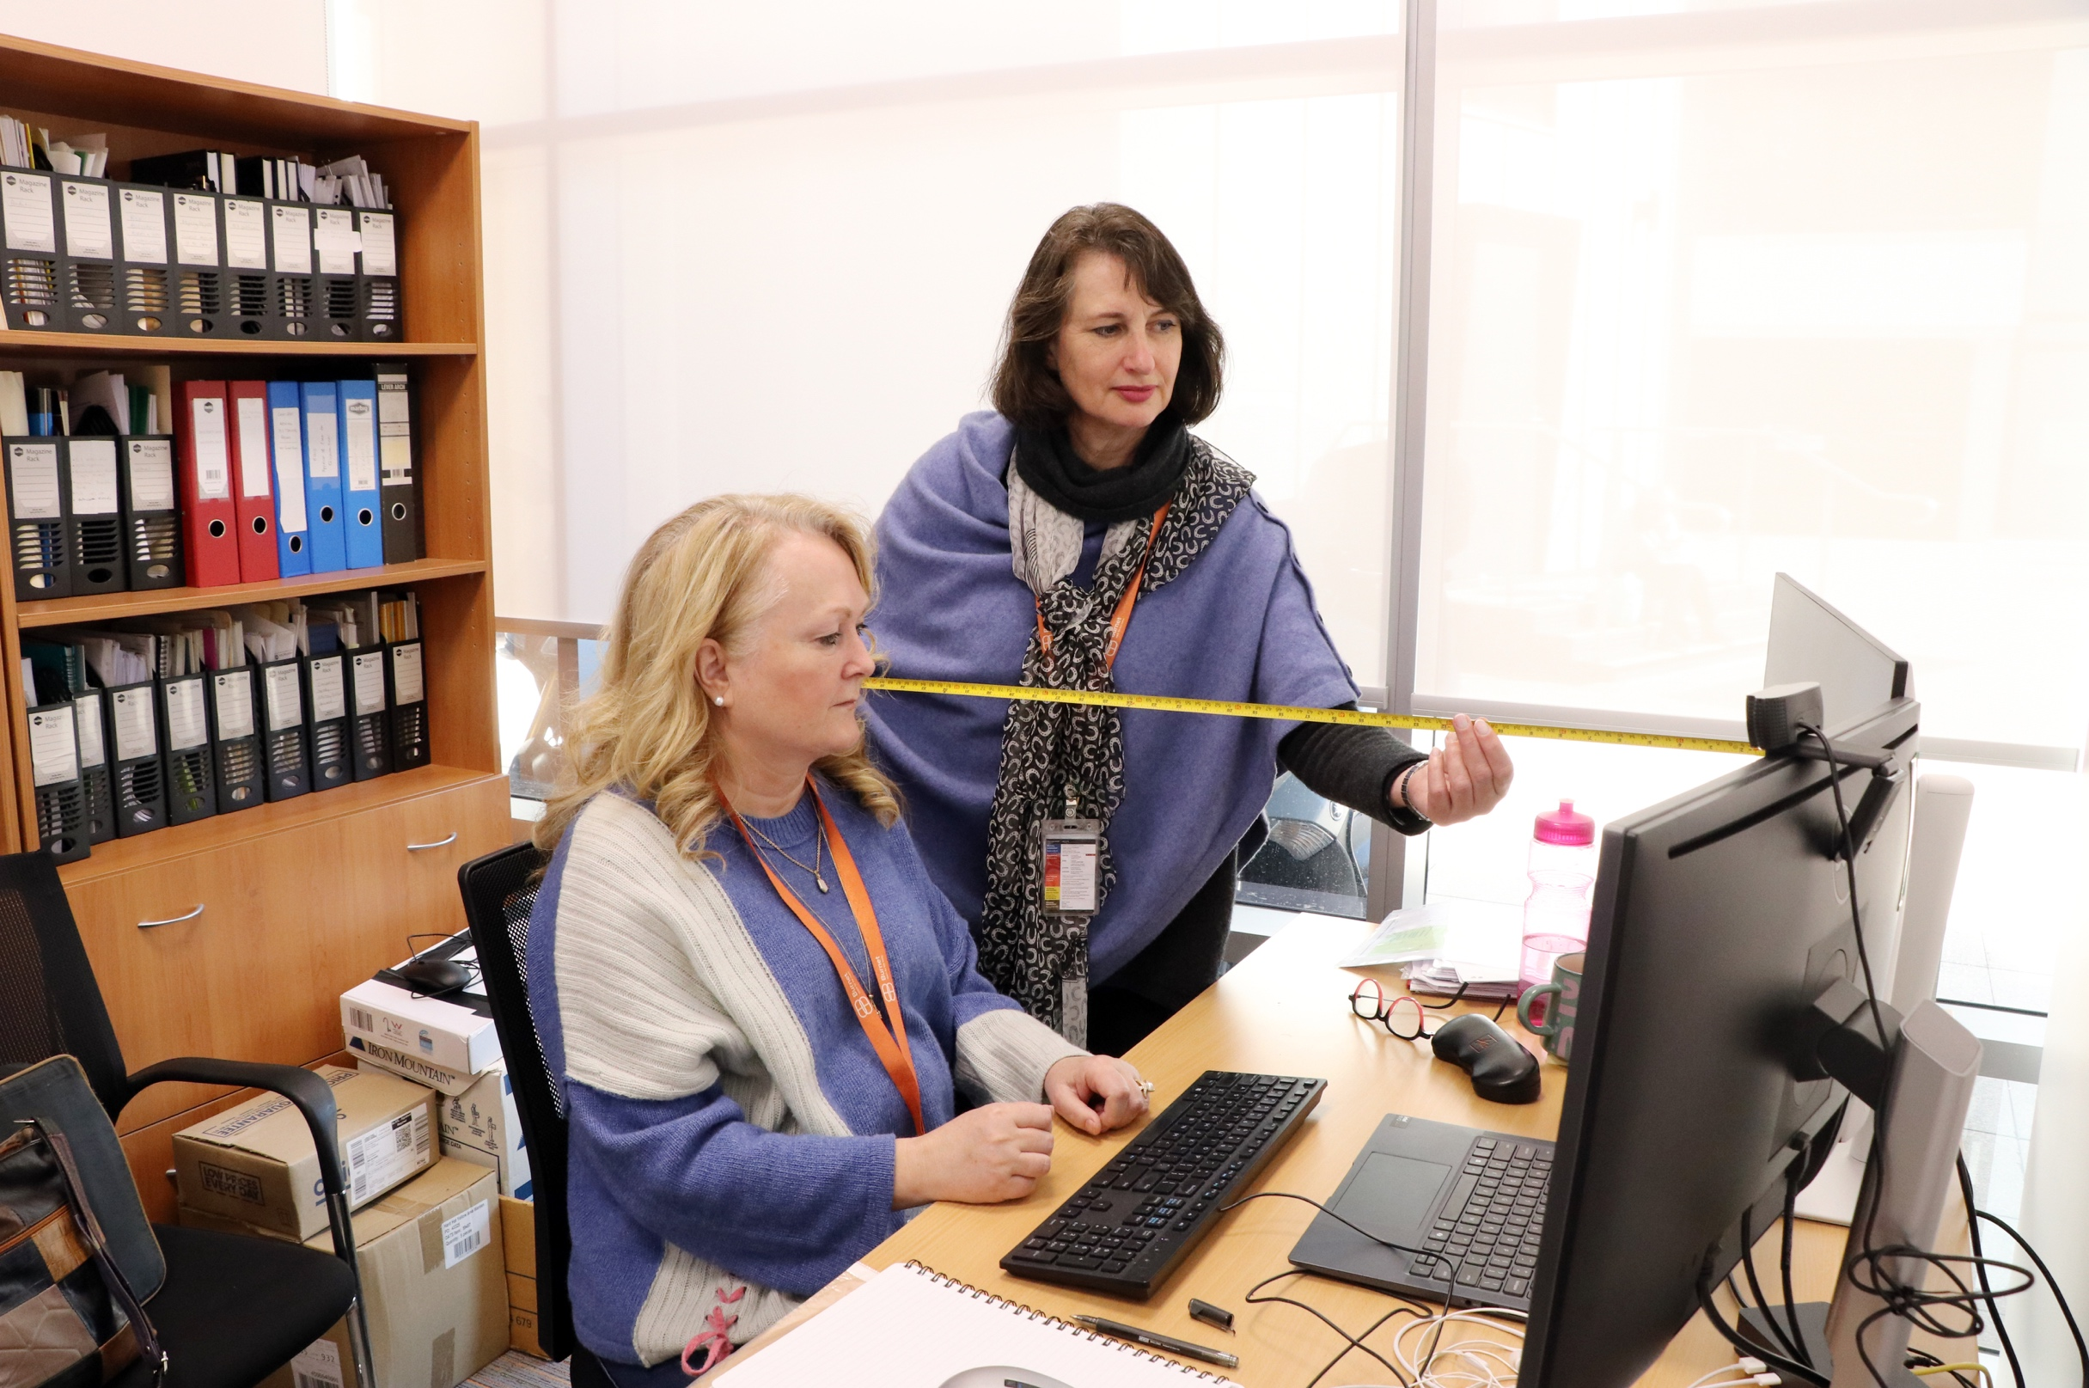
Image: Annabel Teusner and Margarete White perform an ergonomics check, at the Melbourne office.

Dr Thazin La

Research Manager, Health System Research, Burnet Myanmar and country representative of GEDI Committee

Action 5.6: Establish a staff voice committee to facilitate consistent communication with disability inclusion groups in Australia and PNG
“Disability inclusion is critical to our work because people with disabilities are often a hidden population in Myanmar due to systemic neglect, even during times of political stability. You can imagine what happens during a crisis, when the public health system collapses and survival becomes the priority. If we don’t look closely, we may fail to recognise the systemic barriers they face or hear their voices advocating for their rights.
My role includes facilitating accessibility audits, integrating disability inclusion into project planning and activities, and ensuring that the voices and perspectives of people with disabilities are reflected throughout the process. Empowering people with disabilities to take on leadership roles and advocate in policy discussions is essential to driving systemic change and achieving equitable health for all.”
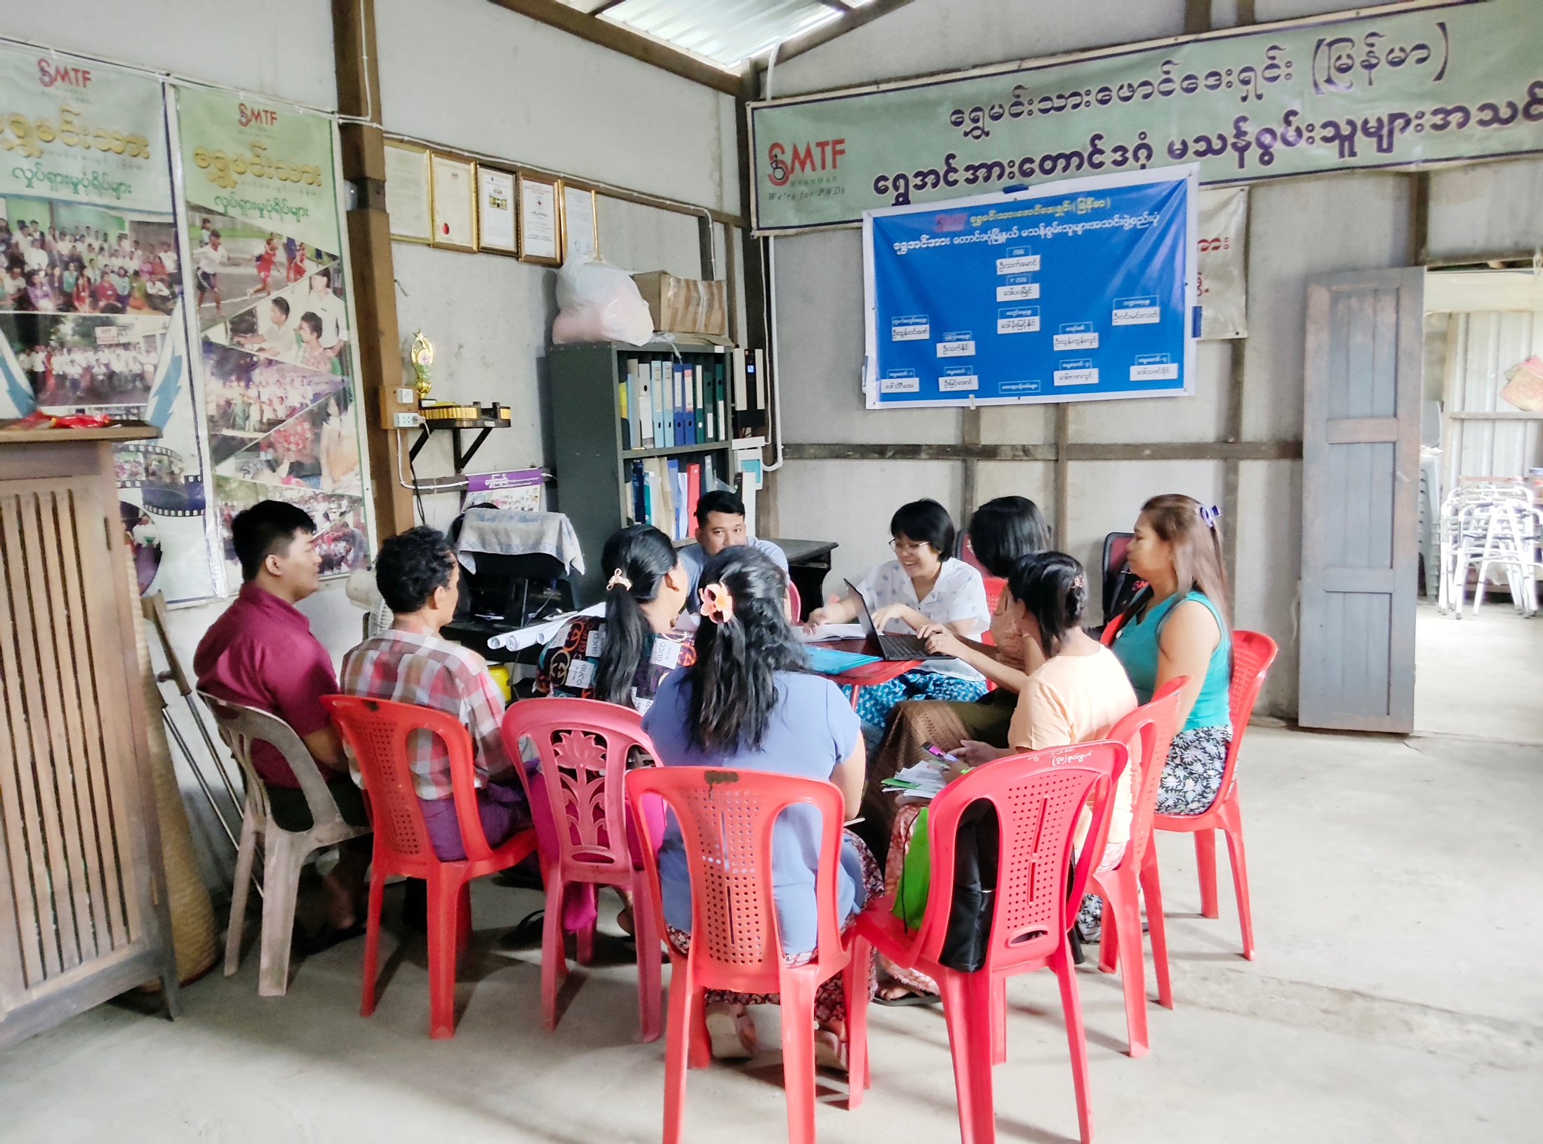
Image: In 2025, Burnet Myanmar Research Manager (Health Systems Research) Thazin La and colleagues meet with a local OPD partner to strengthen disability inclusion.

Merlyn Siware

Data Entry Officer, Disability Inclusion Champion, Burnet PNG

Action 6.8: Identify training needs and develop a training plan to ensure new and existing staff participate in disability inclusion training
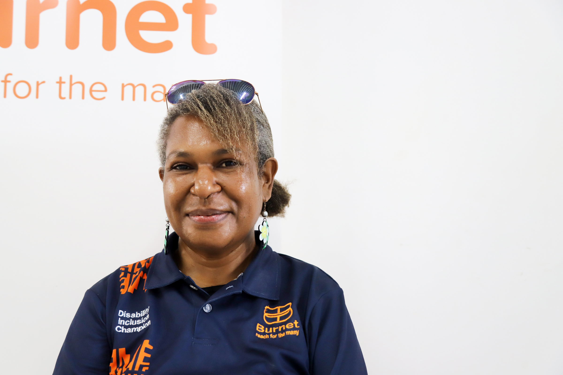

“Tuberculosis (TB) disease, or the TB treatment regime, can cause disabilities including vision, speech, hearing impairments, or even physical impairments. That’s why I see disability inclusion as very important in my context our work in the TB program. It’s our duty to stand up and help so we can provide awareness around disability inclusion to nurses, doctors or other support staff who are dealing directly with our TB patients. We must ensure they are informed on how to assist and support people with disabilities, including through programs that teach local sign language to staff and community members.”
Image: Merlyn Siware, Burnet Daru RID-TB Program; one of the early members of the Disability Champions Group.


Burnet welcomes feedback and comments on our Disability Plan:
Ella Shellshear
Diversity and Inclusion Manager
phone + 61 3 9282 2111
email ella.shellshear@burnet.edu.au
Australia (head office)
85 Commercial Road
Melbourne, Victoria, 3004
Phone + 61 3 9282 2111
Email info@burnet.edu.au
Overseas
Burnet has offices in Papua New Guinea, Myanmar and Vanuatu, and also contributes to research and public health programs in many other countries across Asia, the Pacific, Africa, Europe, and North America.


 burnet.edu.au

